--=================================================================================

--=============================== CIS 310 Exercise 2 ===============================

--=================================================================================

/*

STUDENT NAME: James Cook

STUDENT ID: 5441819

SUBMISSION DATE: 1/19/2024

*/

1. Turn below simplified Crow's foot ERD to business rules.

FIGURE P2.13 THE CROW'S FOOT ERD FOR PROBLEM 13 
adv' 
PROFESSOR 
STUDENT 
CLASS 
teaches 

1. Each professor advises many students.
2. Each student is advised by one professor.
3. Each professor teaches many classes.
4. Each class is taught by one professor.
5. Create simplified Crow’s Foot ERDs to include the following business rules:

--I Recommend drawing/typing using OneNote and attach screenshot.

**Sales company:**

* 1. Each sales representative writes many invoices.
  2. Each invoice is written by one sales representative.
  3. Each sales representative is assigned to one department.
  4. Each department has many sales representatives.
  5. Each customer can generate many invoices.
  6. Each invoice is generated by one customer.

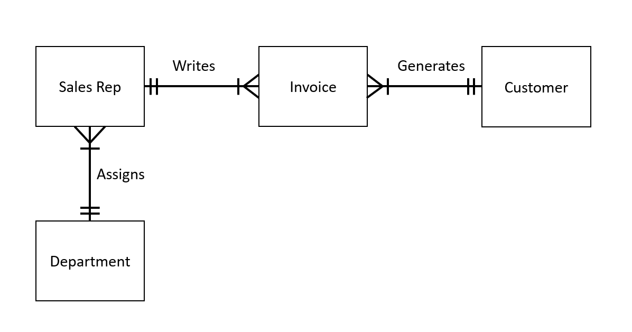

**BooksOnline Store:**

During some period of time, a customer can download many ebooks from BooksOnline. Each of the ebooks can be downloaded by many customers during that period of time.

**MegaCo Corp:**

Each of the MegaCo Corporation’s divisions is composed of many departments. Each department has many employees assigned to it, but each employee works for only one department. Each department is managed by one employee, and each of those managers can manage only one department at a time.

1. Follow all 3 steps of instruction to download, install, and log in to VMWare. Insert screenshot of opening MS Visio within VMWare here. Example screenshot as shown. ***Your screenshot should reflect your full name.***

For any questions or issues, contact [cobhelp@louisville.edu](mailto:cobhelp@louisville.edu) and CC Prof.Wang [jiao.wang@louisville.edu](mailto:jiao.wang@louisville.edu).

<https://business.louisville.edu/current-student-resources/facilities-technology/virtual-desktop/>



